Project Description
This project shows how an Arduino automatically gets sea level barometric pressure for your location using WiFi and the internet. You can use this method to get a full weather forecast.
Many altimeters are based on air pressure, the higher you go, the lower the air pressure. The BMP 280 sensor will give you an accurate reading of air pressure. However, you can't calculate altitude from air pressure alone; you also need to know sea level barometric pressure at your location. A small variation in barometric pressure makes a big difference; a change from 30.00 mmHg to 30.10 mmHg represents a change in altitude of 90 feet!
You could call me an "Altimeter Guy". Of my 5 altimeters, only the GPS-based one doesn't have to be recalibrated when the barometric pressure changes. Sadly, my GPS altimeter is so inaccurate as to be unusable. Two of my altimeters are Arduino based and until now, have needed manual recalibrating whenever the barometric pressure changes. Since the barometric pressure changes constantly, this is a problem.
Electronics
As you can see, the Arduino circuit is very simple; a single sensor (BMP 280) and a single output (servo drive). The real complexity of this project is found in the Arduino program. There are any number of excellent tutorials on the use of the BMP 280 sensor for weather monitoring. The hard part (for me) was to have the program automatically update with the local sea-level barometric pressure.
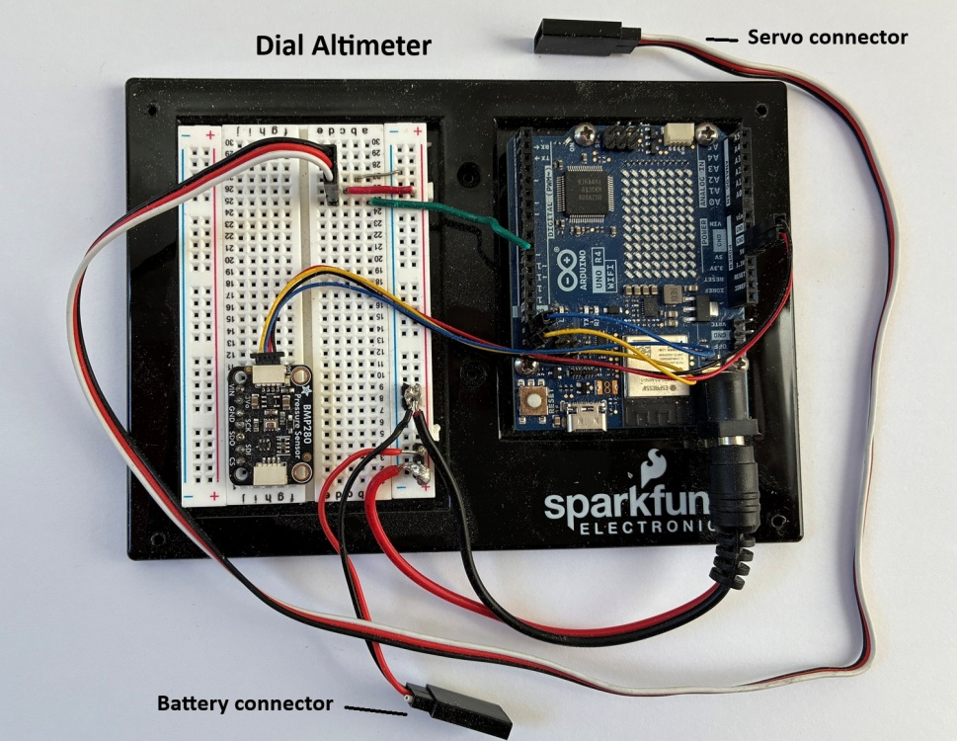
Altimeter construction
The altimeter was constructed by modifying a common garden thermometer. In this case I used an Accu-rite 01360 12.5" thermometer. I removed the face and modified it to indicate altitude rather than temperature. I removed the spring which indicated temperature and installed a servo motor on the back to control the indicator needle. The wooden frame was constructed with some Baltic birch plywood, a poplar 1"x 2", and some dowel scraps. The servo motor mounting place is from Servo City.
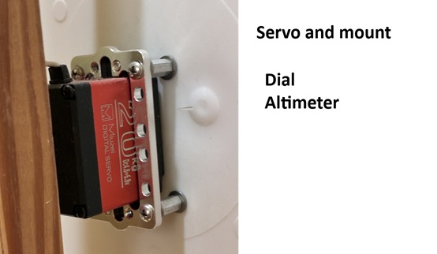
Servo and mount
Arduino Program upgrade goal
I have tried two methods of manually importing barometric pressure into my Arduino altimeters. The first was to open the program, manually update the barometric pressure and then download the program into the Arduino. The second approach was to use the Arduino Cloud and generate a dashboard for my IPad. Then I could manually enter the updated barometric pressure much more easily, but still, manual entry.
My goal for a long time has been for the Arduino-controlled altimeters to automatically update themselves by getting (sea-level) barometric pressure for my location from the internet. Doing this with an Arduino program is far, far beyond my modest programming ability. I decided to forgo the Cloud and try to use my Arduino R4 WiFi with my home WiFi network. I needed expert help. I decided to ask the Github AI to help.
I established a Github repository for the Dial Altimeter and uploaded my original Arduino program to it. I then asked the current Github AI Copilot, (Claude Opus 4.5) how to solve my problem. There was a little back-and-forth as Copilot realized how little I knew, but I ended up with a working program!
The resulting program does the following:
- Connect to WiFi
- Send request to weather service
- Extract barometric pressure from reply
- Calculate altitude and display result
Libraries required:
#include <WiFi.h>
#include <ArduinoJson.h>
#include <Wire.h>
#include <SPI.h>
#include <Adafruit_BMP280.h>
#include "secrets.h"
- Connect to WiFi
Copilot wrote a function "connectToWiFi()" to do this.
void connectToWiFi() {
Serial.print(F("Connecting to WiFi: "));
Serial.println(ssid);
WiFi.begin(ssid, password);
int attempts = 0;
while (WiFi.status() != WL_CONNECTED && attempts < 20) {
delay(500);
Serial.print(".");
attempts++;
}
Serial.println();
if (WiFi.status() == WL_CONNECTED) {
Serial.println(F("WiFi connected!"));
Serial.print(F("IP address: "));
Serial.println(WiFi.localIP());
digitalWrite(LED_BUILTIN, HIGH);
} else {
Serial.println(F("Failed to connect to WiFi"));
}
}
It's important to keep your WiFi password and network name private. The best way to do this is in a separate "H" (header) file. A secrets.h header file template is shown below:
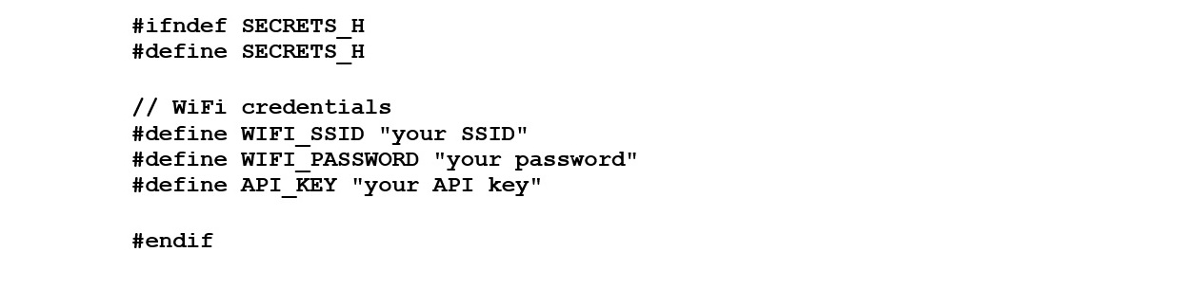
secrets.h file
If you are making a header file with wordpad do not save it as a text file. Save it as a ".H" file.
  - Send request to weather service
This function gets sea level barometric pressure from OpenWeatherMap.org. This function was written by Github Copilot. To access this information, you must set up a free account and then get an API key. Your program will use this API key when it contacts OpenWeatherMap.org for weather information. The Arduino function for getting the barometric pressure is:
void fetchWeatherData() {
if (WiFi.status() != WL_CONNECTED) {
Serial.println(F("WiFi not connected, skipping weather update"));
return;
}
Serial.println(F("Fetching weather data from OpenWeatherMap..."));
WiFiClient client;
if (!client.connect(weatherHost, 80)) {
Serial.println(F("Failed to connect to weather server"));
return;
}
//Build the request URL
String url = "/data/2.5/weather?q=" + String(city) + "&appid=" + String(apiKey) + "&units=metric";
//Send HTTP request
client.print("GET " + url + " HTTP/1.1\r\n");
client.print("Host: " + String(weatherHost) + "\r\n");
client.print("Connection: close\r\n\r\n");
//Read response
String response = "";
unsigned long timeout = millis() + 5000; // 5 second timeout
while (client.connected() || client.available()) {
if (client.available()) {
char c = client.read();
response += c;
}
if (millis() > timeout) break;
}
client.stop();
//Extract JSON from response (skip HTTP headers)
int jsonStart = response.indexOf('{');
if (jsonStart != -1) {
String jsonData = response.substring(jsonStart);
parseWeatherResponse(jsonData);
} else {
Serial.println(F("No JSON found in response"));
}
}
- Extract barometric pressure from reply
The data returned from the Website is in JSON (Java Scrip Object Notation) and must be decoded for the Arduino. The function for this is "parseWeatherResponse". This function was also written by Copilot:
void parseWeatherResponse(String response) {
StaticJsonDocument<512> doc;
DeserializationError error = deserializeJson(doc, response);
if (error) {
Serial.print(F("JSON parse error: "));
Serial.println(error.f_str());
return;
}
//Extract barometric pressure (main.pressure is in hPa, convert to in-Hg)
if (doc.containsKey("main") && doc["main"].containsKey("pressure")) {
float pressureHpa = doc["main"]["pressure"];
barometricPressure = pressureHpa * 0.02953; // Convert hPa to in-Hg
Serial.print(F("Updated barometric pressure: "));
Serial.print(barometricPressure);
Serial.println(F(" in-Hg"));
} else {
Serial.println(F("Pressure data not found in response"));
}
}
  - Calculate altitude and display result
This was part of the original program that I wrote. In this version, the sea level barometric pressure was entered manually, then the program was uploaded to the Arduino. Each time the altimeter was used, this calibration had to happen. The Arduino would get the current pressure from the BMP 280, and calculate the altitude. Next, the servo drive would indicate the altitude. Once every 4 program loops, the servo would be driven to zero feet as a calibration.
float barometricPressure = 30.08; //will be updated from API (in-Hg)
Serial.print(F("Pressure = "));
Serial.print(bmp.readPressure());
Serial.println(" Pa");
Serial.print(F("Barometric Pressure (from API) = "));
Serial.print(barometricPressure);
Serial.println(" in-Hg");
Serial.print(F("Approx altitude = "));
Serial.print(bmp.readAltitude(barometricPressure * 33.86));
Serial.println(" m");
Serial.print(bmp.readAltitude(barometricPressure * 33.86) * 3.2808);
Serial.println(" feet");
Serial.println();
delay(2000);
HEIGHT = (bmp.readAltitude(barometricPressure * 33.86)) * 3.2808; //height in feet
//calibrate to zero loop - not every cycle, though
if (b > 4) { b = 1; }
if (b == 1) {
//take dial to zero feet before displaying altitude
for (i = 0; i < 150; i++) {
digitalWrite(ALT, HIGH); //start servo pulse
delayMicroseconds(2370); //use to calibrate 10/3 2443
digitalWrite(ALT, LOW);
delay(20);
}
}
b = b + 1;
delay(1500);
//take dial to current altitude
for (i = 0; i < 300; i++) {
digitalWrite(ALT, HIGH); //start servo pulse
delayMicroseconds(pulseAlt - HEIGHT * 4.026); //calibrated 10/3
digitalWrite(ALT, LOW);
delay(20);
}
The entire program is linked below. Be sure to put the secrets.h file in the same folder as the ino file.
Dial altimeter file folder
__________Dial altimeter ino file
__________secrets .H file
As a result of all of this, I now have a automatically updating home altimeter! My wife says I could just paint the altitude on a piece of wood and get the same effect, but it's not the same at all.

